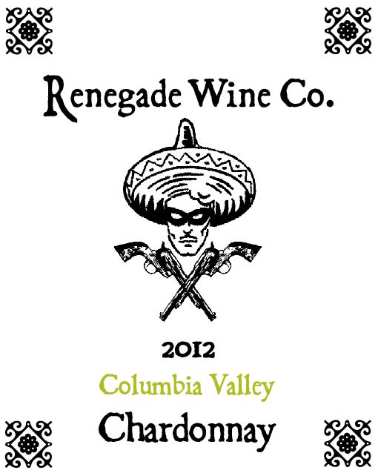

The Renegade Wine Co. is proud to present our newest creation, the 2012 Columbia Valley Chardonnay. 1000 cases of this gem were produced and they WILL go quickly. Aged in all stainless steel, it is a crisper style of Chardonnay, with aromas and flavors of tree fruits like pears and green apples. It is a versatile Chardonnay that will pair well with salads and appetizers, as well as some fish dishes. It will also be a great summertime sipper, unless of course we are sold out by summer! Grab it while you can, be a Renegade!

